LSV PA1

R13943143李秉宸

Result of “Show” after step 3

status

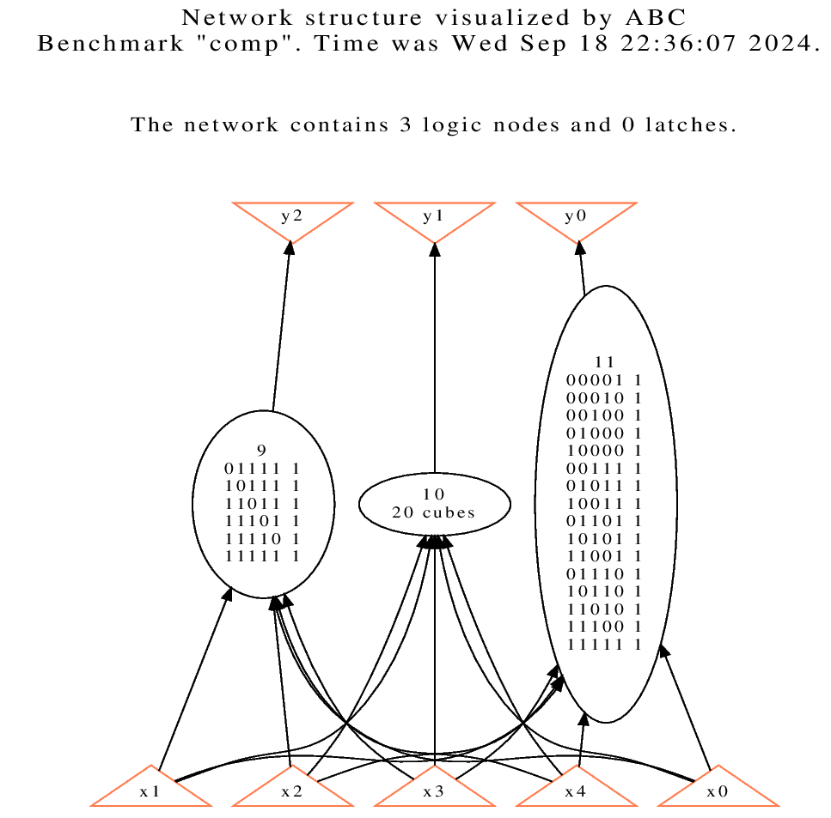

Result of “Show” after step 5

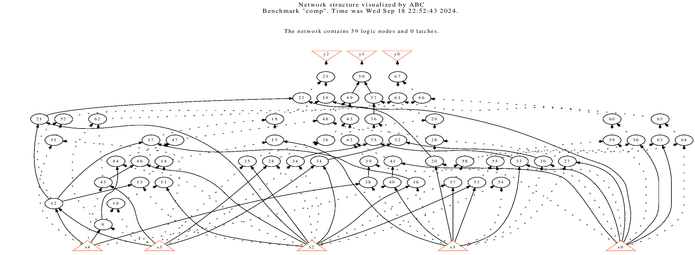

Result of “Show” after step 7

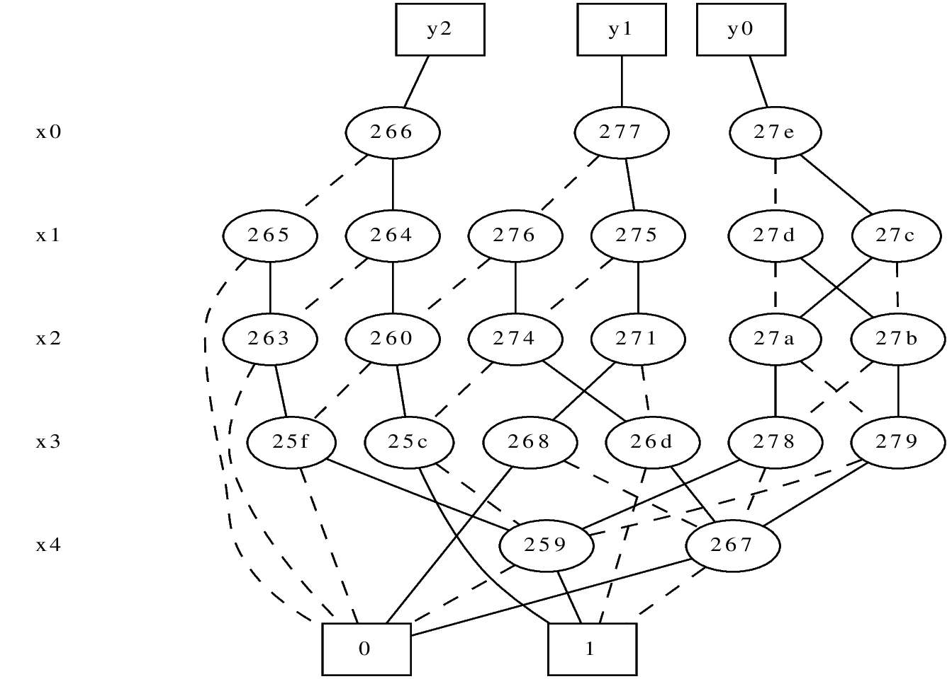

3.

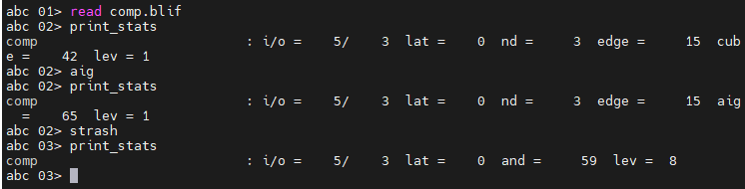

Command "aig": This command changes the node functions into an AIG (And-Inverter Graph) format. The statistics after running aig show that the number of cubes increased from 42 to 65 AIG nodes.

Command "strash": This command restructures the current network into a standard AIG through one-level structural hashing, converting the logic into a network made up entirely of two-input AND gates. After running strash, the statistics show changes in the network's node count (nd), edge count (edge), and AIG node count, now represented as AND gates and logical levels (lev).

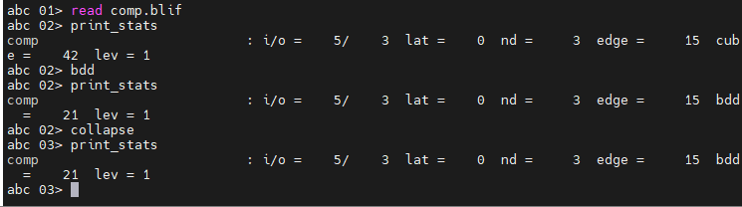

Command "bdd" converts the local node functions into BDDs (Binary Decision Diagrams). After running the “bdd” command, the statistics indicate that cubes are transformed into BDDs.

Command "collapse" recursively composes the fanin nodes into the fanout nodes, creating a network where each output (CO) is driven by a node whose inputs (fanins) are primary inputs (CIs). After running the collapse command, the number of nodes (nd), edges (edge), BDDs (bdd), and levels (lev) remains unchanged.